**Lampiran 1**

Data Penggunaan Obat Gastritis Berdasarkan Zat Aktif

|  |  |  |  |  |  |  |
| --- | --- | --- | --- | --- | --- | --- |
| **No.** | **Zat Aktif Obat Gastritis** | **Bulan** | | | **Jumlah R/** | **(%)** |
| **Okt** | **Nov** | **Des** |
| 1 | Omeprazol Cap | 353 | 333 | 303 | 989 | 27,57 |
|  | Lansoprazol Cap | 364 | 364 | 277 | 1005 | 28,02 |
|  | Jumlah | 717 | 697 | 580 | 1994 | 55,59 |
| 2 | Ranitidin Tab | 26 | 1 | 59 | 86 | 2,40 |
|  | Jumlah | 26 | 1 | 59 | 86 | 2,40 |
| 3 | Sukralfat Syr | 518 | 498 | 412 | 1428 | 39,81 |
|  | Jumlah | 518 | 498 | 412 | 1428 | 39,81 |
| 4 | Antasida Tab | 21 | 31 | 27 | 79 | 2,20 |
|  | Jumlah | 21 | 31 | 27 | 79 | 2,20 |
|  | **Jumlah Total** | **1282** | **1227** | **1078** | **3587** | **100** |

**Lampiran 2**

Resep Kelas Terapi Obat Lain yang di Resepkan dengan obat gastritis

|  |  |  |  |  |  |  |  |  |
| --- | --- | --- | --- | --- | --- | --- | --- | --- |
| No | Kelas Terapi Lain | |  | | | | Jumlah Total R/ | Persentase (%) |
|  |  |  | |
| 1 | **Antiemetik** | | |  |  | |  |  |
|  | Domperidone | |  |  |  | | 906 | 44,61 |
|  | Ondansetron 4 mg | |  |  |  | | 4 | 0,20 |
|  | Jumlah | |  |  |  | | 910 | 44,81 |
| 2 | **Vitamin** | | |  |  | |  |  |
|  | Neurodex | |  |  |  | | 143 | 7,04 |
|  | Mecobalamin | |  |  |  | | 96 | 4,73 |
|  | Sangobion | |  |  |  | | 49 | 2,41 |
|  | Becom C | |  |  |  | | 17 | 0,84 |
|  | Jumlah | |  |  |  | | 305 | 15,02 |
| 3 | **Antibiotik** | | |  |  | |  |  |
|  | Cefixim 100 | |  |  |  | | 142 | 6,99 |
|  | Cefixim 200 | |  |  |  | | 64 | 3,15 |
|  | Levofloxacin 500 | |  |  |  | | 57 | 2,81 |
|  | Ciprofloxacin 500 | |  |  |  | | 23 | 1,13 |
|  | Metronidazol 500 | |  |  |  | | 11 | 0,54 |
|  | Jumlah | |  |  |  | | 297 | 14,62 |
| 4 | **Antiinflamasi** | | |  |  | |  |  |
|  | Etoricoxib | |  |  |  | | 95 | 4,68 |
|  | Natrium diklofenak 50 | |  |  |  | | 89 | 4,38 |
|  | Meloxicam 15 mg | |  |  |  | | 26 | 1,28 |
|  | Dexamethason 0,5 mg | |  |  |  | | 11 | 0,54 |
|  | Methylprednisolon 4 mg | |  |  |  | | 6 | 0,30 |
|  | Jumlah | |  |  |  | | 227 | 11,18 |
| 5 | **Analgetik Antipiretik** | | |  |  |  | |  |
|  | Parasetamol 500mg | |  |  |  | 42 | | 2,07 |
|  | Asam Mefenamat 500 mg | |  |  |  | 20 | | 0,98 |
|  | Tramadol 50 mg | |  |  |  | 11 | | 0,54 |
|  | Analsik 500 mg | |  |  |  | 9 | | 0,44 |
|  | Antalgin | |  |  |  | 4 | | 0,20 |
|  | Analtram 500 mg | |  |  |  | 2 | | 0,10 |
|  | Jumlah | |  |  |  | 88 | | 4,33 |
|  |  | |  |  |  |  | |  |
|  |  | |  |  |  |  | |  |
|  | |
|  | |
|  | |
| 6 | **Dan lain-lain** | |  |  |  | |  |  |
|  | Gabapentin | | |  |  | | 64 | 3,15 |
|  | Propanolol | |  |  |  | | 21 | 1,03 |
|  | Betahistin | |  |  |  | | 17 | 0,84 |
|  | Simvastatin 20 mg | |  |  |  | | 12 | 0,59 |
|  | Ambroxol | |  |  |  | | 8 | 0,39 |
|  | Albuforce | | |  |  | | 8 | 0,39 |
|  | Laxadin Susp | |  |  |  | | 8 | 0,39 |
|  | Flunarizin 5 mg | |  |  |  | | 8 | 0,39 |
|  | Salofalk | |  |  |  | | 7 | 0,34 |
|  | Furosemid 40 mg | | |  |  | | 6 | 0,29 |
|  | Transamin 500 mg | |  |  |  | | 5 | 0,25 |
|  | Metformin 500 mg | |  |  |  | | 5 | 0,25 |
|  | Cetirizin | |  |  |  | | 5 | 0,25 |
|  | Lactulac Susp | |  |  |  | | 5 | 0,25 |
|  | Spironolactone 100 | |  |  |  | | 5 | 0,25 |
|  | Ramipril 2,5 | |  |  |  | | 4 | 0,20 |
|  | Lisinopril 5 | |  |  |  | | 2 | 0,10 |
|  | Loperamid | | |  |  | | 2 | 0,10 |
|  | Antihemorhoid Supp | |  |  |  | | 2 | 0,10 |
|  | Glimepiride 1 mg | |  |  |  | | 2 | 0,10 |
|  | Ardium | |  |  |  | | 2 | 0,10 |
|  | Urispas | | |  |  | | 2 | 0,10 |
|  | Gentamisin salep | | |  |  | | 2 | 0,10 |
|  | Candesartan | | |  |  | | 2 | 0,10 |
|  | Jumlah | | |  |  | | 204 | 10,04 |
|  | **Jumlah Total** | | |  |  | | 2031 | 100 |

**Lampiran 3**

Contoh Resep

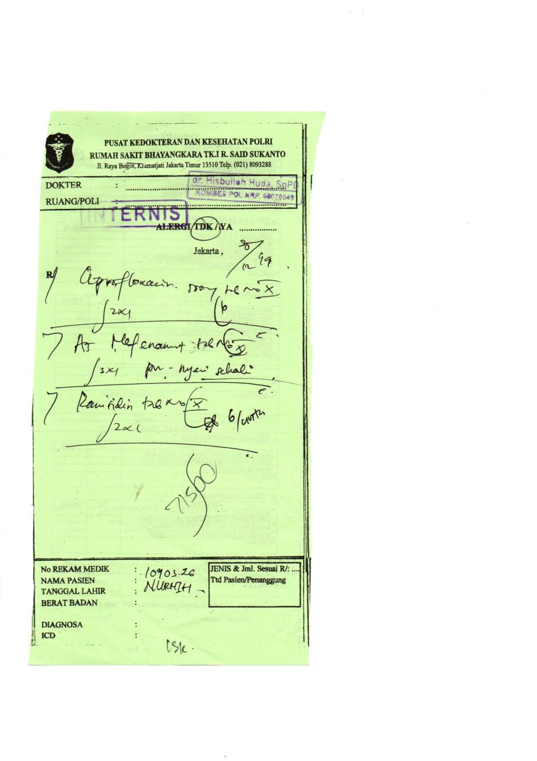

**Lampiran 4**

Surat Permohononan Izin Penelitian dari Poltekkes Kemenkes Jakarta II

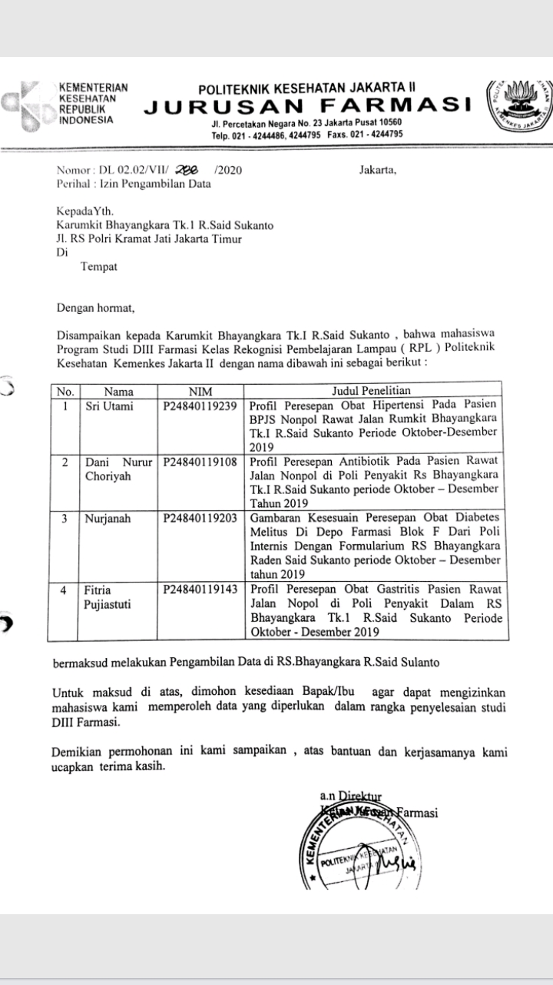

**Lampiran 5**

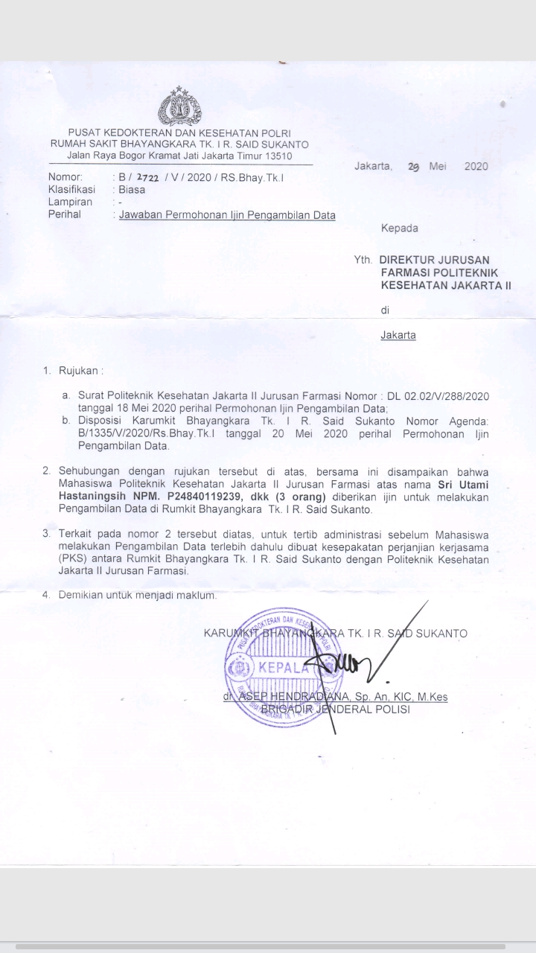Surat Izin Penelitian dari RS Bhayangkara Tk. I R. Said Sukanto